Job Aggregator Set up Guide:
Start with running backend with cmd : uvicorn main:app –reload
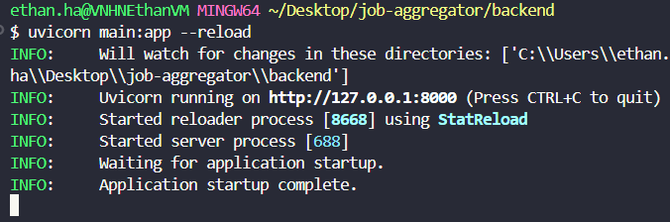
Cause using VM with company laptop cannot connect to cloud MongoDB, so I create the local one to store. Need to install MongoDB Community Server
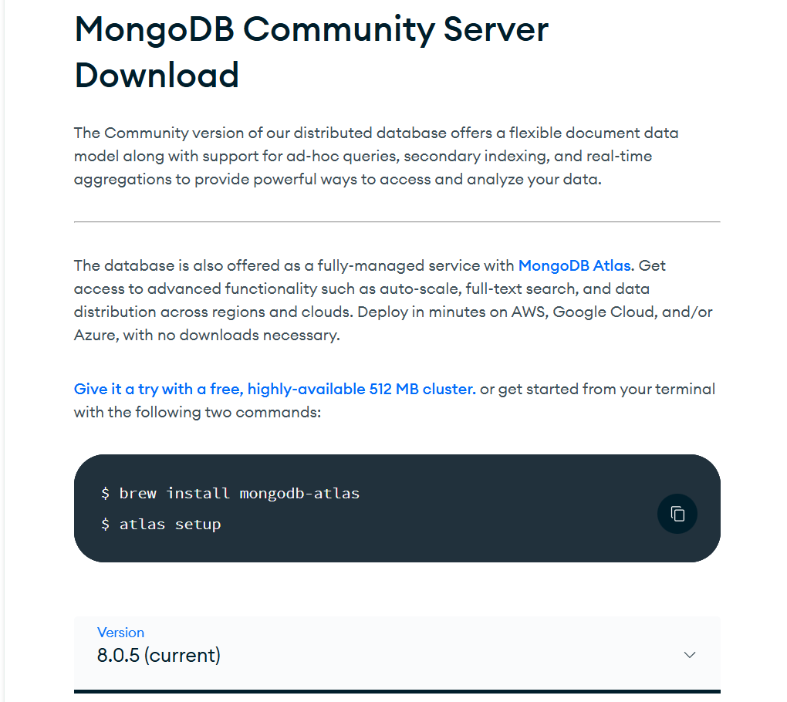
After successfully installing, please run this job to create database and collection first
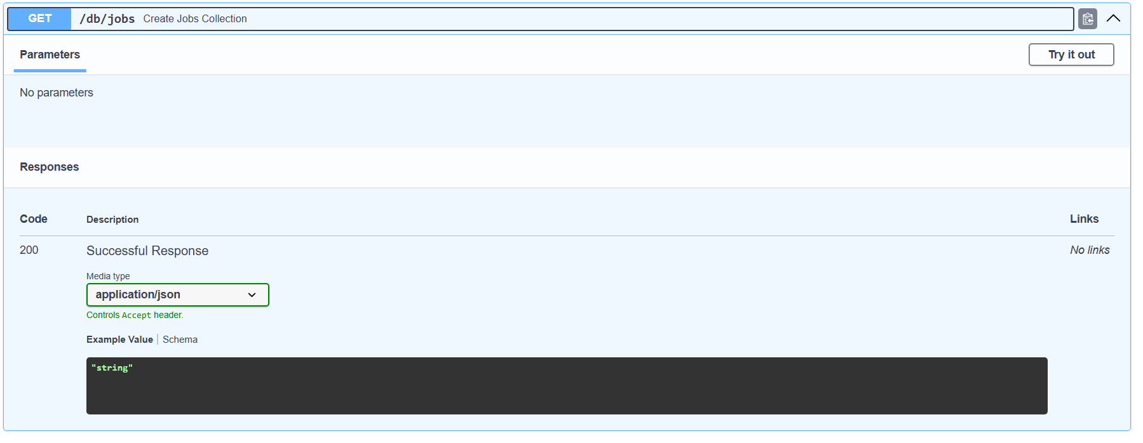
To mock data for the jobs collection, can use this job for mock
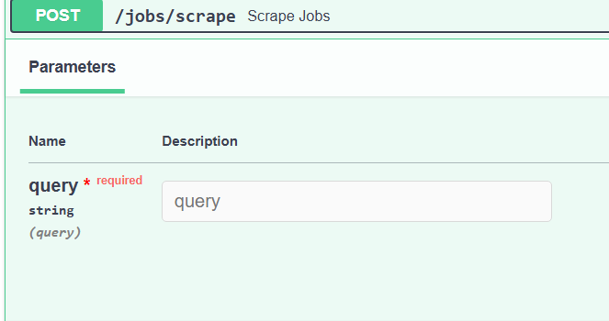
Then run front end:
Npm i
Npm run dev
